# Use Cases

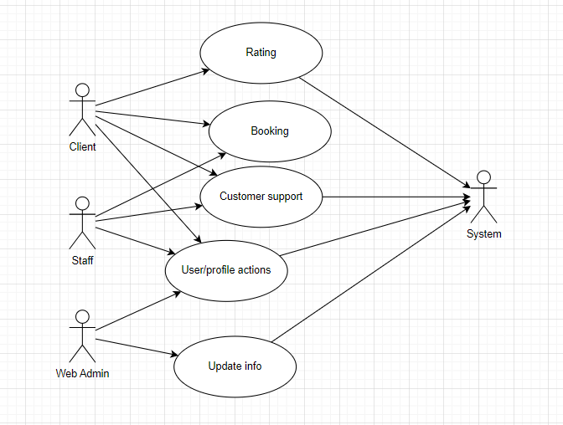

## Use case 1: Booking

This includes all tasks associated with bookings. Users who have logged in will be able to make and cancel their own bookings. They will also be able to view their bookings at any time. Hotel staff will also have to approve or deny these bookings. Once these bookings have been confirmed by hotel staff the client can pay for the booking through the site.

## Use case 2: User profile actions

This includes everything having to do with user accounts. All users will be able to log in and clients will be able to register new accounts. All users will be able to view their profile information and edit it, or delete their accounts if they wish.

## Use case 3: Admin functionality

This mainly involves web admin functionality, to edit hotel and room information. This is differentiated super admins such that web admins will only have control over own hotels. Web admins will also have different levels of privileges will be able to different tasks, depending on their level of privilege. Web admins with the highest level of privilege will also be responsible for registering staff and new web admins in their hotel.

## Use case 4: Customer support

Customer support will be provided to users, allowing them to ask any questions they have regarding their profile, bookings or any other information about the site or hotels. Staff will be handling these queries where possible, but they may be passed on to Web admins if needed.

## Use case 5: Rating hotels

Uses will be able to leave and view hotel ratings, allowing users to get a sense of whether or not it is somewhere they would want to stay and allowing users to express their opinions on their experiences.

# ERD

There will be 8 database models in total, including users, divided into staff, clients and web admins, hotels, which will have rooms and rating, and bookings made by users.

## Users

Modules: User, Client, Staff, Web Admin

All user profile will have a user entry, including the basic information needed by all users, inkling a name, and contact information. Users will then be broken down into different types with different roles, including clients, or people who want to by hotel rooms, staff, who will handle user interactions with their hotel, including bookings and customer support, and web admins, who will manage the hotel information for their hotel.

## Hotels

Modules: Hotel, Room, Rating

Hotels will have their own model, including general information, including location and contact information to be displayed to the user about their hotel. They will also have rooms, with each having its own price and description, and ratings, made by users based on their experience at the hotel if they have stayed there.

## Bookings

Modules: Bookings

There will also be a bookings model. These will have information about the booking, including who booked the room, when they are staying and in what room (which will have an associated hotel). Once the user has made a booking, it will then have to be approved by a member of staff at that hotel, or removed from the system.

## Customer support

Modules: Query, Feedback

There will be 2 modules for customer support, a queries module, which will contain information on the customers query, including what hotel their query is with, the date at which it was sent, the user that sent it and the query itself. The second module, for feedback, will contain information on the response to the user query, including the member of staff who responded to the query, their response, and when the response was sent. The staff members response will be sent to the user by email, but will also be stored in the database to keep a record of its information.